LALR / SLR Parsers

🧠 What Are LALR and SLR Parsers?
# Source: AI Source: Provided by: [Data Path: Persons Table -> ID Column: 1, Name_En Column: Motasem Essam] -> From: [Chatgpt (GPT‑5 Mini)] on [1/26/2026]
LALR (Look-Ahead LR) and SLR (Simple LR) are types of bottom-up parsers used in compiler construction. They are variants of LR parsers, optimized for smaller size and faster performance, yet still capable of parsing most programming languages.

🧩 Quick Comparison Table
# Source: AI Source: Provided by: [Data Path: Persons Table -> ID Column: 1, Name_En Column: Motasem Essam] -> From: [Chatgpt (GPT‑5 Mini)] on [1/26/2026]
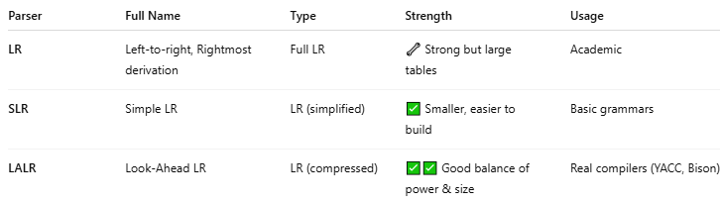

Parser | Full Name | Type | Strength | Usage
LR | Left-to-right, Rightmost derivation | Full LR | 🔧 Strong but large tables | Academic
SLR | Simple LR | LR (simplified) | ✅ Smaller, easier to build | Basic grammars
LALR | Look-Ahead LR | LR (compressed) | ✅✅ Good balance of power & size | Real compilers (YACC, Bison)

🔧 What They All Do
# Source: AI Source: Provided by: [Data Path: Persons Table -> ID Column: 1, Name_En Column: Motasem Essam] -> From: [Chatgpt (GPT‑5 Mini)] on [1/26/2026]
All LR-based parsers use:
- A stack to hold symbols and states
- A parsing table (with SHIFT, REDUCE, GOTO actions)
- A state machine that processes input left to right
- A rightmost derivation in reverse
They differ only in how the parsing table is built and optimized.

🔍 1. SLR Parser (Simple LR)
# Source: AI Source: Provided by: [Data Path: Persons Table -> ID Column: 1, Name_En Column: Motasem Essam] -> From: [Chatgpt (GPT‑5 Mini)] on [1/26/2026]
- Based on LR(0) items + Follow sets
- Uses very basic lookahead (just the FOLLOW set of the non-terminal)
- Easy to implement, but may reject some valid grammars

🔸 Pros:
# Source: AI Source: Provided by: [Data Path: Persons Table -> ID Column: 1, Name_En Column: Motasem Essam] -> From: [Chatgpt (GPT‑5 Mini)] on [1/26/2026]
- ✅ Small table size
- ✅ Fast parsing
- ✅ Good for simple languages

🔸 Cons:
# Source: AI Source: Provided by: [Data Path: Persons Table -> ID Column: 1, Name_En Column: Motasem Essam] -> From: [Chatgpt (GPT‑5 Mini)] on [1/26/2026]
- ❌ Fails on some grammars due to limited context
- ❌ Not suitable for full programming languages

🔍 2. LALR Parser (Look-Ahead LR)
# Source: AI Source: Provided by: [Data Path: Persons Table -> ID Column: 1, Name_En Column: Motasem Essam] -> From: [Chatgpt (GPT‑5 Mini)] on [1/26/2026]
- Improves SLR by using more precise lookahead
- Merges LR(1) states with identical LR(0) cores
- Used in YACC, Bison, and many real-world compilers

🔸 Pros:
# Source: AI Source: Provided by: [Data Path: Persons Table -> ID Column: 1, Name_En Column: Motasem Essam] -> From: [Chatgpt (GPT‑5 Mini)] on [1/26/2026]
- ✅ Can handle complex languages like C, Java
- ✅ Table size much smaller than full LR(1)
- ✅ Powerful and efficient

🔸 Cons:
# Source: AI Source: Provided by: [Data Path: Persons Table -> ID Column: 1, Name_En Column: Motasem Essam] -> From: [Chatgpt (GPT‑5 Mini)] on [1/26/2026]
- ❗ Slightly more complex than SLR
- ❗ Still can't handle every ambiguous grammar

🎯 Example Usage
# Source: AI Source: Provided by: [Data Path: Persons Table -> ID Column: 1, Name_En Column: Motasem Essam] -> From: [Chatgpt (GPT‑5 Mini)] on [1/26/2026]
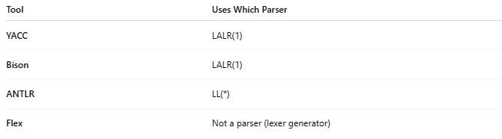
Tool | Uses Which Parser
YACC | LALR(1)
Bison | LALR(1)
ANTLR | LL(*)
Flex | Not a parser (lexer generator)

🧠 Visual Flow of LALR Parser
# Source: AI Source: Provided by: [Data Path: Persons Table -> ID Column: 1, Name_En Column: Motasem Essam] -> From: [Chatgpt (GPT‑5 Mini)] on [1/26/2026]
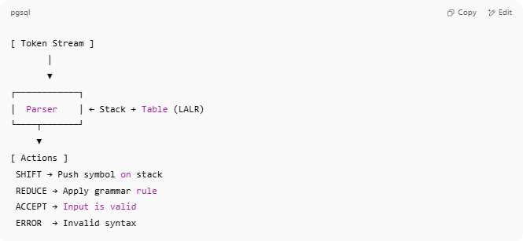
[ Token Stream ]
│
▼
┌────────────┐
│ Parser │ ← Stack + Table (LALR)
└────┬───────┘
▼
[ Actions ]
SHIFT → Push symbol on stack
REDUCE → Apply grammar rule
ACCEPT → Input is valid
ERROR → Invalid syntax

✅ Summary
# Source: AI Source: Provided by: [Data Path: Persons Table -> ID Column: 1, Name_En Column: Motasem Essam] -> From: [Chatgpt (GPT‑5 Mini)] on [1/26/2026]
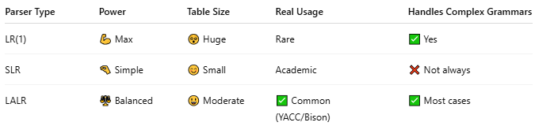

Parser Type | Power | Table Size | Real Usage | Handles Complex Grammars
LR(1) | 💪 Max | 😵 Huge | Rare | ✅ Yes
SLR | 🤏 Simple | 😊 Small | Academic | ❌ Not always
LALR | ⚖️ Balanced | 😃 Moderate | ✅ Common (YACC/Bison) | ✅ Most cases

